Section 2: Flowcharts
Prime Number FlowChart
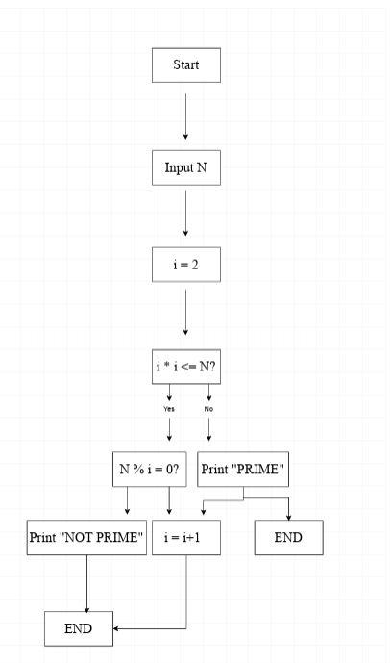

Number Digit Reversal Flowchart